A Project Report on

**“Design and Optimization of Heat Exchanger”**

Submitted By

**Mr.** **Akshay Patil (71831711E)**

**Mr. Nikhil Patil (71831720D)**

**Mr. Rushikesh Phanse (71831815D)**

**Mr. Narendra Saralkar (71831847B)**

Under The Guidance

**Prof. Sachin Borade**



**Department of Mechanical Engineering**

**Zeal Education Society’s**

**Zeal College of Engineering and Research**

**Narhe, Pune -411041**

**[2020-2021]**

Zeal Education Society’s

Zeal College of Engineering and Research

Narhe, Pune -411041



**CERTIFICATE**

This is to certify that

***Mr. Akshay Patil (71831711E)***

***Mr. Nikhil Patil (71831820D)***

***Mr. Rushikesh Phanse (71831815D)***

***Mr. Narendra Saralkar (71831847B)***

have successfully completed the project work entitled **“*Design and Optimization of Heat Exchanger”*** under my supervision, in the partial fulfillment of Bachelor of Engineering- Mechanical Engineering of Savitribai Phule Pune University.

Date : 14/06/2021

Place : Pune

**Prof. Sachin Borade**

Project Guide External Examiner

**Prof. Godase S. M.** **Dr. A. M. Kate**

Head of Department Principal

**ACKNOWLEDGEMENT**

I take this opportunity to express my sincere gratitude towards the Department of Mechanical Engineering, ZCOER, PUNE that gave me an opportunity for presentation of my Project Stage-I in their esteemed organization.

I would like to express my sincere thanks to my Project guide **Prof. Sachin Borade** and Head of the Department **Prof. Godase S. M.** without whose guidance and adequate facilities I would not have completed my Project Stage-I, his valuable advice made it easy for me to proceed for this Project Stage-I.

I express my sincere thanks to Project Co-Ordinator **Prof A. M. Kasar / Prof. S.V. Mutalikdesai** for his constant support and experienced guidance and providing me precious help and advice without which the successful completion of this Project Stage I would not have been possible. I am also thankful to **Dr A. M. Kate** Principal, ZCOER, PUNE for giving me necessary resources and support to complete my Project Stage-I.

Last but not the least, I thank all others, and especially my classmates and my family members who in one way or another helped me in the successful completion of this work.

Mr. **Akshay Patil** (**71831711E**)

Mr. **Nikhil Patil** (**71831720D**)

Mr. **Rushikesh Phanse** (**71831815D**)

Mr. **Narendra Saralkar** (**71831847B**)

**CONTENTS**

| **Sr. No.** | **Description** | | **Page. No.** |
| --- | --- | --- | --- |
| *Acknowledgement* | | | *3* |
| *List of Figures* | | | *5* |
| *List of Tables* | | | *6* |
| *Abbrviation* | | | *7* |
| *Abstract* | | | *8* |
| **1** |  | **Introduction** | **9** |
|  | 1.1 | Classification of Heat Exchange | 11 |
|  | 1.2 | Problem Statement | 13 |
|  | 1.3 | Objective | 13 |
|  | 1.4 | Scope | 13 |
|  | 1.5 | Methodology | 14 |
|  | 1.6 | Organization of Dissertation | 16 |
| **2** |  | **Literature Review** | **17** |
| **3** |  | **Design Flow Process** | **20** |
|  | 3.1 | Basic and Detail Part List | 20 |
|  | 3.2 | Techanical Specification | 21 |
|  | 3.3 | Design Calculations | 22 |
|  | 3.4 | Material Selection | 29 |
|  | 3.5 | 3D Modeling | 33 |
|  | 3.6 | FEA Analysis | 34 |
|  | 3.7 | Cost Estimation | 43 |
| **4** |  | **Result** | **47** |
| **5** |  | **Conclusion and Future Scope** | **48** |
|  | 5.1 | Future Scope | 49 |
|  |  | **References** | **50** |

**LIST OF FIGURES**

| **Figure No.** | **Name of Figure** | **Page No.** |
| --- | --- | --- |
| Figure 1.1 | Classification Of Heat Exchanger | 11 |
| Figure 1.2 | Classification Of Tubular Heat Exchanger | 11 |
| Figure 1.3 | Classification Of Shell and Tube Heat Exchanger | 11 |
| Figure 1.4 | Methodology | 14 |
| Figure 1.5 | Figure 1.5 Project Process Flowchart | 15 |
| Figure 3.1 | Diagram indicating leaking paths for flow bypassing the tube matrix, both through the baffle clearances between the tube matrix and shell | 23 |
| Figure 3.2 | Material Property Charts List | 29 |
| Figure 3.3 | Fig. 3.3 Young’s Modulus Vs Density Chart | 30 |
| Figure 3.4 | Strength Vs Density Chart | 30 |
| Figure 3.5 | Young’s Modulus Vs Strength | 31 |
| Figure 3.6 | Specific Modulus Vs Specific Strength | 31 |
| Figure 3.7 | Fracture Toughness Vs Young’s Modulus | 32 |
| Figure 3.8 | Equivalent stress for saddle support | 35 |
| Figure 3.9 | Displacement for saddle support | 35 |
| Figure 3.10 | Factor of safety for saddle support | 36 |
| Figure 3.11 | Equivalent stress for girth flange | 38 |
| Figure 3.12 | Displacement for girth flange | 38 |
| Figure 3.13 | Factor of safety for girth flange | 39 |
| Figure 3.14 | Equivalent stress for fitting pipe | 41 |
| Figure 3.15 | Displacement for fitting pipe | 41 |
| Figure 3.16 | Factor of safety for fitting pipe | 42 |

**LIST OF TABLES**

| **Table No.** | **Name of Table** | **Page No.** |
| --- | --- | --- |
| Table 3.1 | List of Parts | 20 |
| Table 3.2 | Tube side input data | 21 |
| Table 3.3 | Shell side input data | 21 |
| Table 3.4 | FEA results for saddle support | 34 |
| Table 3.5 | FEA results for saddle support | 36 |
| Table 3.6 | FEA results of girth flange | 37 |
| Table 3.7 | EA results of fitting pipe | 40 |

**ABBRVIATIONS**

| **Symbols** | **Description** |
| --- | --- |
| TEMA | Tubular Exchanger Manufacturers Associationr |

**ABSTRACT**

Thermal performance and Pressure drop are the major parameters for an evaluation of shell and tube type of Heat Exchanger. The path followed by the stream fluid and orientation of Baffle are the properties on which thermal performance and pressure drop are depend respectively. In shell and Tube type of Heat Exchange Optimization is carried out to reduce weight of saddle support and subsequent corresponding result and also manufacturing cost of Heat Exchanger. Design of Heat Exchange is done by the reference of TEMA (Tubular Exchangers Manufacturer Association) standards and using solid Works software and SFD analysis using solid works simulation as well Material selection by Ashby chart. All the parameters have been taken from the relevant industry code and standards.

***Keywords: -*** *Pressure Drop, TEMA standard, Ashby chart*

**CHAPTER 1**

**INTRODUCTION**

Heat exchangers are one of the mostly used equipment in the process industries. Heat

Exchangers are used to transfer heat between two process streams. One can realize their usage that any process which involve cooling, heating, condensation, boiling or evaporation will require a heat exchanger for these purpose. Process fluids, usually are heated or cooled before the process or undergo a phase change. Different heat exchangers are named according to their application. For example, heat exchangers being used to condense are known as condensers, similarly heat exchanger for boiling purposes are called boilers. Performance and efficiency of heat exchangers are measured through the amount of heat transfer using least area of heat transfer and pressure drop. A more better presentation of its efficiency is done by calculating over all heat transfer coefficient. Pressure drop and area required for a certain amount of heat transfer, provides an insight about the capital cost and power requirements (Running cost) of a heat exchanger. Usually, there is lots of literature and theories to design a heat exchanger according to the requirements.

Heat exchangers are of two types:-

* Where both media between which heat is exchanged are in direct contact with each other is Direct contact heat exchanger.
* Where both media are separated by a wall through which heat is transferred so that they never mix, Indirect contact heat exchanger.

A typical heat exchanger, usually for higher pressure applications up to 552 bars, is the shell and tube heat exchanger. Shell and tube type heat exchanger, indirect contact type heat exchanger. It consists of a series of tubes, through which one of the fluids runs. The shell is the container for the shell fluid. Generally, it is cylindrical in shape with a circular cross section, although shells of different shape are used in specific applications. For this

particular study shell is considered, which is generally a one pass shell. A shell is the most commonly used due to its low cost and simplicity, and has the highest log-mean temperature-difference (LMTD) correction factor. Although the tubes may have single or multiple passes, there is one pass on the shell side, while the other fluid flows within the

shell over the tubes to be heated or cooled. The tube side and shell side fluids are separated by a tube sheet.

Baffles are used to support the tubes for structural rigidity, preventing tube vibration and sagging and to divert the flow across the bundle to obtain a higher heat transfer coefficient. Baffle spacing (B) is the centre line distance between two adjacent baffles, Baffle is provided with a cut (Bc) which is expressed as the percentage of the segment height to shell inside diameter. Baffle cut can vary between 15% and 45% of the shell inside diameter. In the present study 25% baffle cut (Bc) is considered. In general, conventional shell and tube heat exchangers result in high shell-side pressure drop and formation of recirculation zones near the baffles. Most of the researches now a day are carried on helical baffles, which give better performance then single segmental baffles but they involve high manufacturing cost, installation cost and maintenance cost. The effectiveness and cost are two important parameters in heat exchanger design. So, In order to improve the thermal performance at a reasonable cost of the Shell and tube heat exchanger, baffles in the present study are provided with some inclination in order to maintain a reasonable pressure drop across the exchanger.

The complexity with experimental techniques involves quantitative description of flow phenomena using measurements dealing with one quantity at a time for a limited range of problem and operating conditions. Computational Fluid Dynamics is now an established industrial design tool, offering obvious advantages. In this study, a full 360° CFD model of shell and tube heat exchanger is considered. By modelling the geometry as accurately as possible, the flow structure and the temperature distribution inside the shell are obtained.

**1.1 Classification Of Heat Exchanger :**

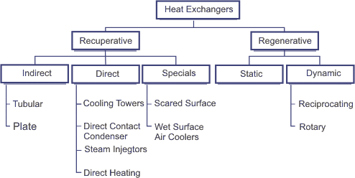

*Figure 1.1 Classification Of Heat Exchange*r

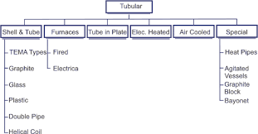

*Figure 1.2 Classification Of Tubular Heat Exchanger*

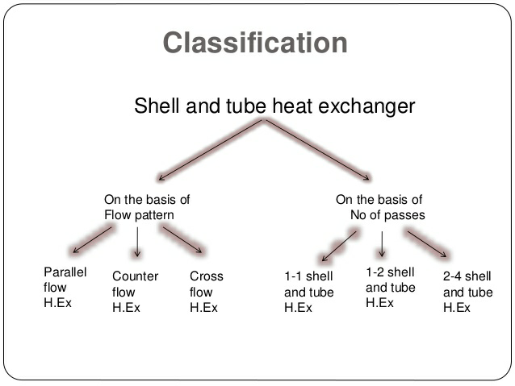

*Figure 1.3 Classification Of Shell and Tube Heat Exchanger*

**1.2 Problem Statement**

Design a double stack heat exchanger for industrial purpose(paper pulp industry application) to increase heat transfer rate and reduce pressure drop across existing baffles and tubes using TEMA standard.

**1.3** **Objective**

1. To increase the heat transfer rate.
2. To reduce Pressure drop of existing baffle and tube.
3. To reduce vibrations in saddle support.
4. To reduce the weight of saddle.

**1.4 Scope**

1. Material selection using ASHBY charts.
2. Engineering Calculations using TEMA standard
3. 3D Design using Solid works.
4. FEA Analysis using Solid works Simulation.
5. Engineering Costing.
6. Preparation of Bill of Material.

**1.5 Methodology**

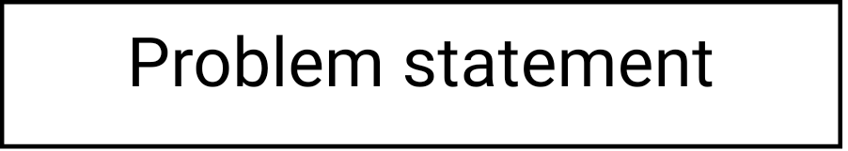







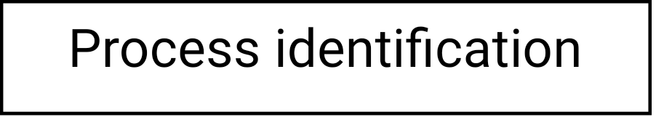













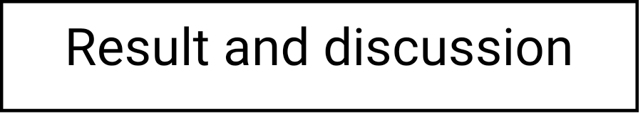





*Figure 1.4 Methodology*

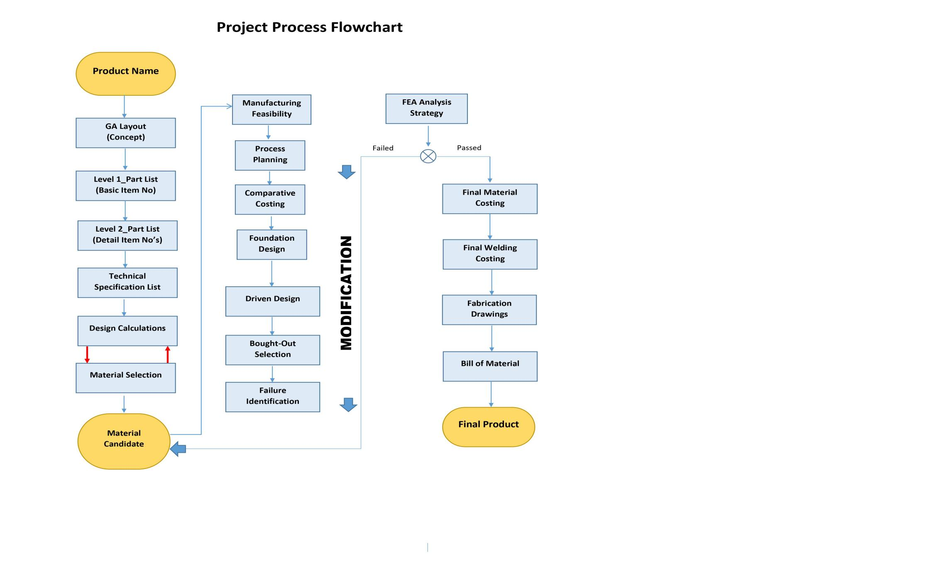

*Figure 1.5 Project Process Flowchart*

**1.6 Organization of Dissertation**

The project work has been organized as follows:

**Chapter 1:** Briefly introduces about the history of Heat Exchanger. It also includes the classification, problem statement, objective, scope and methodology to complete the project with project process flow chart.

**Chapter 2:** Gives a brief description about study of Literature survey by different investigators in the field of heat exchanger.

**Chapter 3:** Gives detail about design flow process.

**Chapter 4:** Describes the result and discussion about the topic.

**Chapter 5:** It also includes the conclusion drawn from the results obtained from the analysis. This chapter also discussed the scope for future work.

**CHAPTER 2**

**LITERATURE REVIEW**

The purpose of this chapter is to provide a literature review of past research effort such

as journals or articles related to shell and tube heat exchanger and Finite element analysis

whether on two dimension and three dimension modelling.

Moreover, review of other relevant research studies are made to provide more

information in order to understand more on this research.

After studying the Literature it can be concluded that a lot of work has been done in the field of Design & analysis of heat exchanger. Pramod S. Purandare et al. [2014] In this paper An experimental analysis is carried out to study the heat transfer phenomenon in conical coil heat exchanger with cone angle 90 degree. M. Ghazikhani et al. [2013] the experimental investigation of the effect of wedge-shaped tetrahedral VGs (vortex generator) on a gas liquid finned tube heat exchanger was studied using irreversibility analysis. Dillip Kumar Mohanty et al. [2012] In that paper the statistical analysis is used as an invaluable tool for investigation of performance of a shell and tube heat exchanger under fouling condition. A. I. Zinkevich et al. [2010]. In this paper shown that non uniform distribution of liquid flow among the tubes of a shell and tube apparatus has to be taken into account in determining the efficiency of heat transfer. The authors of this paper have proposed a method for taking this non uniformity into account and for analyzing its effect on the intensity of heat transfer. LIU Wei et al. [2009] in this paper heat transfer enhancement in the core flow, and with the analysis of the disturbance mechanism of longitudinal flow, a new type of high efficiency and low resistance heat exchanger with rod-vane compound baffler was designed and investigated numerically. Seong Yeon Yoo et al. [2009] The heat transfer rate of the external tube surface of the heat exchanger for a closed wet cooling tower can be divided into sensible and latent heat transfer rates. These in turn are expressed by heat and mass transfer coefficients.

Ahmerrais khan and sarfaraz khan focus on the various researches on Computational Fluid Dynamics (CFD) analysis in the field of heat exchanger. It has been found that CFD has been employed for the various areas of study in various types of heat exchanges Different turbulence models available in general purpose commercial CFD tools i.e. standard, realizable and RNG k −ε RSM, and SST k −ε in conjunction with velocity-pressure coupling schemes such as SIMPLE, SIMPLEC, PISO and etc. have been adopted to carry out the simulations. The quality of the solutions obtained from these simulations are largely within the acceptable range proving that CFD is an effective tool for predicting the behavior and performance of a wide variety of heat exchangers. 2. Philippe Wildi-Tremblay in his paper explains the procedure for minimizing the cost of a shell-and-tube heat exchanger based on genetic algorithms (GA). The global cost includes the operating cost (pumping power) and the initial cost expressed 3. in terms of annuities. He took some geometrical parameters of the shell-and-tube heat exchanger as the design variables and the genetic algorithm is applied to solve the associated optimization problem. It is shown that for the case that the heat duty is given, not only can the optimization design increase the heat exchanger effectiveness significantly, but also decrease the pumping power dramatically. 4. SiminWangJianWenYanzhong Li in his paper shows that the configuration of a shell-and-tube heat exchanger was improved through the installation of sealers in the shell-side. The gaps between the baffle plates and shell is blocked by the sealers, which effectively decreases the short-circuit flow in the shellside. The results of heat transfer experiments show that the shell-side heat transfer coefficient of the improved heat exchanger increased by 18.2–25.5%, the overall coefficient of heat transfer increased by 15.6–19.7%, and the efficiency increased by 12.9–14.1%. Pressure losses increased by 44.6–48.8% with the sealer installation, but the increment of required pump power can be neglected compared with the increment of heat flux. The heat transfer performance of the improved heat exchanger is intensified, which is an obvious benefit to the optimizing of heat exchanger design for energy conservation. 5. A.Pignotti in his paper established relationship between the effectiveness of two heat exchanger configurations which differ from each other in the inversion of either one of two fluids. This paper provides the way by which if the effectiveness of one combination is known in terms of heat capacity rate ratio and NTUs then the effectiveness of the other combination can be readily known. 6. V.K. Patel and R.V. Rao explores the use of a non-traditional optimization technique; called particle swarm optimization (PSO), for design optimization of shell-and-tube heat exchangers from economic view point. Minimization of total annual cost is considered as an objective function. Three design variables such as shell internal diameter, outer tube diameter and baffle spacing are considered for optimization. Two tube layouts viz. triangle and Square are also considered for optimization. Four different case studies are presented to demonstrate the effectiveness and accuracy of proposed algorithm. The results of optimization using PSO technique are compared with those obtained by using genetic algorithm (GA). 7. W.J.Marner, A.E.Bergles and J.M. Chenoweth studied the tubular enhanced surfaces used in shell-and-tube heat exchangers. As an initial step, the subject is limited to single-phase pressure drop and heat transfer; however, both tube side and shell side flows are taken into consideration. A comprehensive list of commercial augmented tubes which may be considered for use in shell-and-tube exchangers is given, along with a survey of the performance data which are available in the literature. They discussed the standardized data format which uses the inside and outside envelope diameters as the basis for presenting the various geometrical, flow, and heat transfer parameters for all tubular enhanced surfaces.

**CHAPTER 3**

**DESIGN FLOW PROCESS**

**3.1 Basic and Detail part list:**

By the reference of Tubular Exchanger Manufacturers Association (TEMA) standards and Research Papers for Heat Exchanger the following detailed part list has been created:

| 1 | Bottom support rear assembly |
| --- | --- |
| 2 | Front channel cover assembly |
| 3 | Front support assembly without pad |
| 4 | Shellside pipe spool assembly |
| 5 | 1.5 inch 300 LB. BLIND NOZZ T5 |
| 6 | 1.5 inch 300 LB. RFLWN NOZZ T6 RC |
| 7 | 10 inch 300 LB. RFWN T1 |
| 8 | 10 inch nozzle pipe T2 |
| 9 | Channel cover assembly with vent nozzle |
| 10 | Girth flange |
| 11 | Rare channel cover gasket |
| 12 | Rare channel rolled cylinder |
| 13 | Nozzle S1 H type |
| 14 | Nozzle S2 H type |
| 15 | Pad bottom support front |
| 16 | Rare tubesheet |
| 17 | Shell rolled cylinder course 1 |
| 18 | Shell rolled cylinder course 2 |
| 19 | Shell rolled cylinder course 7 |
| 20 | Tie rod longest |
| 21 | Baffle A |
| 22 | Baffle B |
| 23 | Rear channel assembly |
| 24 | Tube (lofin like) |

*Table 3.1 List of Parts*

**3.2 Technical Specifications:**

As per customer requirement technical specifications are as follows:

Tube side input data:-

| Tube side input data:-  Flow |  |  |  | Kg/h | 120000 |
| --- | --- | --- | --- | --- | --- |
| Inlet Temperature | |  |  | °C | 80 |
| Outlet Temperature | |  |  | °C | 50.00 |
| Density |  |  |  | Kg/m³ | 971.79 |
| Viscosity |  |  |  | cP | 0.354 |
| Specific Heat |  |  |  | Kcal/Kg.°C | 0.92 |
| Thermal Conductivity | |  |  | Kcal/m.h.°C | 332 |
| Viscosity at Wall temperature | | |  | cP | 0.16 |
| Allowable Pressure Drop | |  |  | bar | 0.5 |
| Fouling Factor |  |  |  | m².h.°C/Kcal | 0.0004 |

*Table 3.2 Tube side input data*

Shell side input data:-

| Flow |  |  |  | Kg/h | 9000 |
| --- | --- | --- | --- | --- | --- |
| Inlet Temperature | |  |  | °C | 20 |
| Outlet Temperature | |  |  | °C | 57.17 |
| Density |  |  |  | Kg/m³ | 998.21 |
| Viscosity |  |  |  | cP | 1 |
| Specific Heat |  |  |  | Kcal/Kg.°C | 0.99 |
| Thermal Conductivity | |  |  | Kcal/m.h.°C | 12 |
| Viscosity at Wall temperature | | |  | cP | 0.59 |
| Allowable Pressure Drop | |  |  | bar | 0.5 |
| Fouling Factor |  |  |  | m².h.°C/Kcal | 0.0004 |

*Table 3.3 Shell side input data*

**3.3 Design Calculations:**

**Bell-Delware Method**

**Historical Development of the Delaware Method:**

The Department of Chemical Engineering at the University of Delaware started in 1947, a comprehensive research program on shell-side design of shell- and-tube heat exchangers. This project is called Delaware Project and it finished in 1963. In 1947, the project started under ASME sponsorship using funds from the Tubular Exchanger Manufacturers Association, the American Petroleum Institute, Standard Oil Development Co., Andale Company, Downingtown Iron Works, Davis Engineering Co., E.I. du Pont de Nemours and Company, and York Corporation. The principal investigators were Professors Olaf Bergelin and Allan Colburn of the University of Delaware.

In 1947, the experimental program started with measurements of heat transfer and pressure drop during flow across ideal tube banks and hence the various design features characteristic of shell-and-tube heat exchangers were introduced in commercial use. Then several baffle cut and spacing configurations were studied inside a cylindrical shell with no baffle leakage first. But baffle leakages between baffles and the shell and between the tubes and baffles were added afterwards. Finally, the bypass flow around the bundle between the outer tube limit and the shell inner diameter was investigated. The first report was published in 1950 and the second report, in 1958. In 1960, a preliminary design method for E shell heat exchangers was issued. In 1963, the final report was published.

**Simplified Mechanisms of Shell-Side Flow:**

As can be seen from Figure 4.3, five different streams are identified on the shell-side. Stream B is the main cross flow stream flowing through one window across the cross flow section and out through the opposite window.

However, there are four other streams because of the mechanical clearances required in a shell-and-tube heat exchanger. One of them is the A stream that leaks through the clearance between the tubes and the baffle, from one baffle compartment to the next. There is also the C stream which is the bundle bypass stream and which flows around the tube bundle between the outermost tubes in the bundle and the inside of the shell. The E stream flows through the clearance between the baffles and the inside diameter of the shell. Finally, the F stream flows through any channels within the tube bundle caused by the provision of pass dividers in the exchanger header. Therefore, it exists only in multiple tubepass configurations.

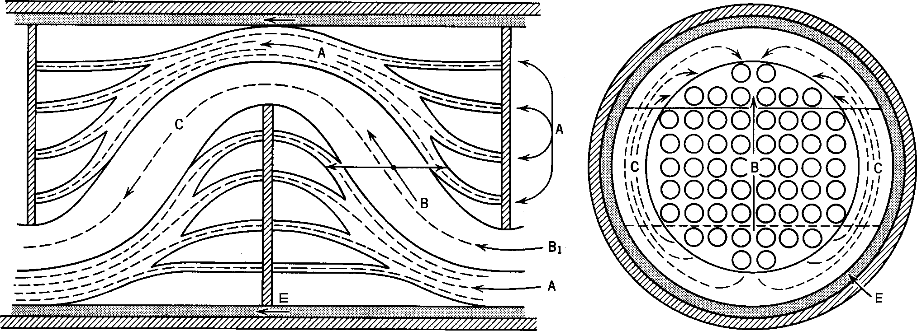

*Figure 3.1 Diagram indicating leaking paths for flow bypassing the tube matrix, both through the baffle clearances between the tube matrix and shell*

Figure 3.1 is an idealized representation of course because the streams defined above are not exactly as they are shown in the figure. They form and mix and interact with one another and a more complete analysis is needed for the shell-side flow but this analysis cannot be carried out exactly because of a lack of knowledge of the turbulent flow structures on the shell-side.

All the streams other than B affect the performance of the essential B stream. The first effect of the various streams is that they reduce the B stream and therefore the local heat transfer coefficient. Secondly, they change the shell-side temperature profile. The Delaware method lumps these two effects together into a single correction.

Bell (1963) [1] developed therefore Delaware method in which correction factors were introduced for the following elements:

1. Leakage through the gaps between the tubes and the baffles and the baffles and the shell, respectively.
2. Effect of the baffle configuration (i.e., a recognition of the fact that only a fraction of the tubes are in pure cross flow).
3. Bypassing of the flow around the gap between the tube bundle and the shell.
4. Effect of adverse temperature gradient on heat transfer in laminar flow.

Delaware method is a rating analysis. In a rating problem, the process specifications which are the flow rates, outlet temperatures (if length is to be found), inlet temperatures, physical properties, fouling characteristics, and geometrical parameters of the heat exchanger which are the shell inside diameter, the outer tube limit, the tube diameter, the tube layout, the baffle spacing and the baffle cut are all given and the length (if not given) and the duty (if length is given) and pressure drops for both cases are calculated.

**Calculation of Bell-Dellware Method:**

1. **Shell-side heat transfer coefficient, h**

Using the correction factors for nonidealities of baffled flow, the actual shell-side heat transfer coefficient hs is expressed as

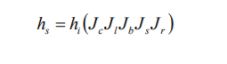

where hi is the heat transfer coefficient for pure cross flow in ideal tube bank, Jc is the segmental baffle window correction factor, Jlis the baffle leakage correction factor, Jb is the bypass correction factor, tube bundle to shell, Jsis the unequal inlet/outlet baffle spacing correction factor, applicable only if such differences exist, and Jris the laminar heat transfer correction factor, applicable for Res<100. These correction factors may be particularly important for U-tube bundles, where larger outlet baffle spacing will always exist unless special provisions are made, such as if the outlet nozzle is located so that the U-bend area is ineffective, which is the safe procedure. Otherwise, it is assumed that Bo=1.2Dsfor calculation of Js, because of the large bypass areas, which have not been accounted for in the calculation of hi. To see the overall effectiveness of the baffled exchanger as compared to ideal tube bank, it is considered useful to calculate Jtot, as the product of all the correction factors. In general, Jtot should never be less than 0.4, and preferably ≥0.5 for a good design.

The ideal tube bank-based coefficient is calculated from

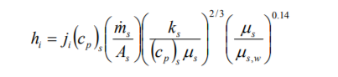

shell-side fluid, As is the cross flow area at the centerline of the shell for one cross flow between two baffles given by Eq. (4.18), ksis the thermal conductivity for shell-side fluid, *µ*sis the viscosity of the shell-side fluid, *µ*s,w is the viscosity of the shell-side fluid at the wall layer, and jiis the Colburn j-factor for an ideal tube bank.

jiand fi are also given in graphical forms for ideal tube bank as a function of shell side Reynolds number, Res=dom size. the Reynolds number is based on the outside tube diameter and on the minimum cross-section flow area at the shell diameter. Friction coefficients for ideal tube banks are also given on the same graphs for the pressure drop calculations.

For computer applications, the ideal values of jiand fi are curve-fitted as

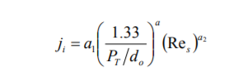

where

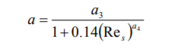

and

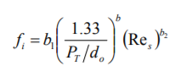

Where

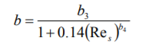

a1 , a2 , a3 , a4 , b1 , b2 , b3 and b4 are correlation coefficients listed in Table

Correlation coefficients for jiand fi

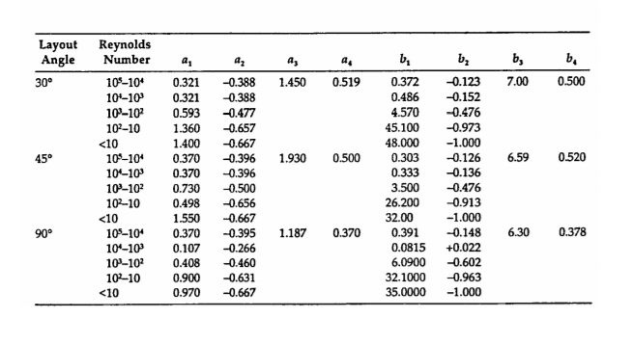

1. **Shell-side pressure drop, ∆ps**

For a shell-and-tube type heat exchanger with bypass and leakage streams, the total nozzle-to-nozzle pressure drop is calculated as the sum of the following three components:

1. By considering the pressure drop in the interior cross flow section (baffle tip

to baffle tip), the combined pressure drop of all the interior cross flow section

is

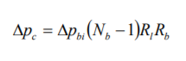

where Nbis the number of baffles, Rlis the leakage correction factor (A and E streams), Rbis the bypass correction factor. Typically, Rb=0.5 to 0.8, depending on the construction type and number of sealingstrips, and Rl=0.4 to 0.5. The section of the exchanger covered by this pressure drop component. ∆pbi is the pressure drop in an equivalent ideal tube bank in one baffle compartment of central baffle spacing and it is calculated from

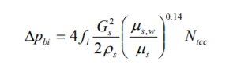

where fi is the friction coefficient, Gsis the mass velocity of the shell-side fluid, *ρ*sis the shell-side fluid density, *µ*sis the shell-side fluid viscosity, *µ*s,w is the viscosity of shell-side fluid evaluated at wall surface temperature, and Ntccis the number of tube rows crossed in one cross flow section, that is, between the baffle tips.

2. The pressure drop in the window is affected by leakage but not bypass. The combined pressure drop ∆pw in all the windows crossed, which equals Nb. The Delaware method offers two different correlations for ∆pw, one for turbulent flow and one for laminar flow, based for simplicity on the shell-side cross flow Res. Both correlations employ for mass velocity calculations, the geometric mean of the cross flow area Smgiven by and the window net area Sw given by

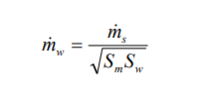

flow mass velocity through segmental baffle window. The baffle window ∆pwis defined as follows:

For turbulent flow, Res≥100 , ∆pw is

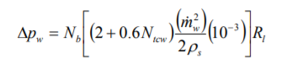

The factor 2 accounts for velocity heads due to the window turnaround, and 0.6 accounts for the cross flow frictional effects over Ntcwwhich is the number of tube rows crossed in the window,

For laminar flow, Res<100 , ∆pw is

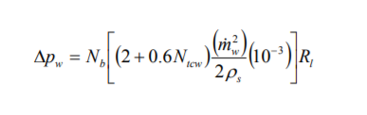

where Dw is the hydraulic diameter of the baffle window defined. The first term in brackets accounts for the cross flow and longitudinal friction, respectively; the second term in brackets represents two velocity heads for the turnaround in the window. It should be noted that only the leakage correction factor Rlis applied to the baffle window ∆pw, whereas the bypass correction factor Rbis considered not applicable. Comparing the resuls, at the break point of Res=100 , it is found that the values are not equal, because they are based on different principles. In such cases, the larger value should be taken as a safety factor.

3. The pressure drop in the entrance and exit sections which is affected by bypass but not by leakage. The flow region of the end zones differs from the central cross flow zone in the following respects: (a) the number of tube rows crossed includes the tube rows in the entry or exit window, Ntcw. (b) the leakage streams have not yet developed (entry) or just joined the main stream (outlet) in the end zones, and therefore the leakage correction factor is not applicable. (c) the baffle spacing in the end zones may differ from the central spacing, especially for U-tube bundles. An end zone correction factor Rs is therefore used. Then the pressure drop in the two end zones ∆pe is

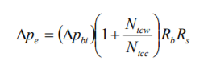

where ∆pbiis calculated, Rbis the bypass correction factor, and Rs is the end zone correction factor. For all baffle spacings equal, Rs=2 . Finally, the total shell-side pressure drop ∆ps, excluding nozzles, is

∆ps=∆pc+∆pw+∆pe

The pressure drop in the nozzles must be calculated separately and added to the total pressure drop.

**3.4 Material Selection:**

Material selection is based on:

* ASHBY charts
* ASME (American society of mechanical engineering)

Step wise process for material selection by ASHBY charts:

1) Screening

2) Selecting property chart

3) Selecting guidelines

4) Potential candidate material

5) Gather material cost

6) Calculate relative cost

7) Calculate scale value

8) Calculate weighing factor

9) Performance index calculation

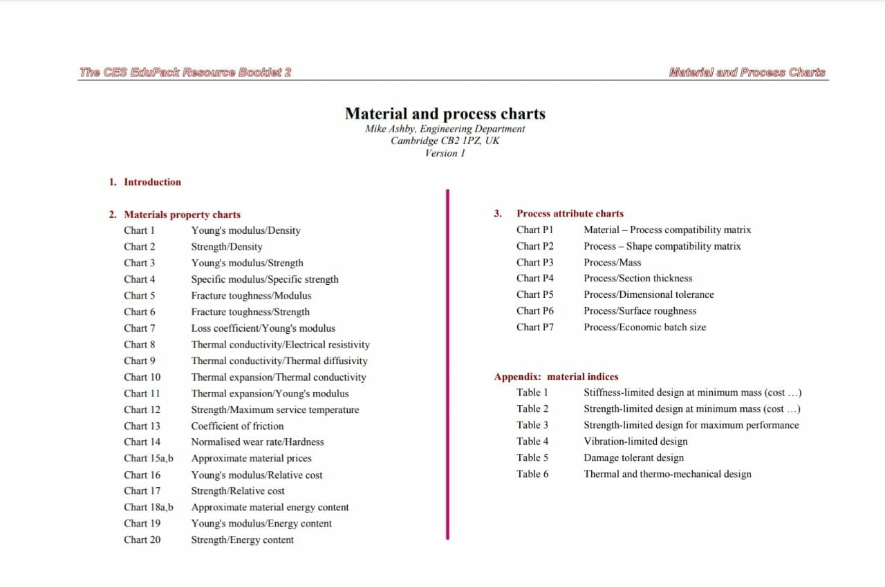

*Fig. 3.2 Material Property Charts List*

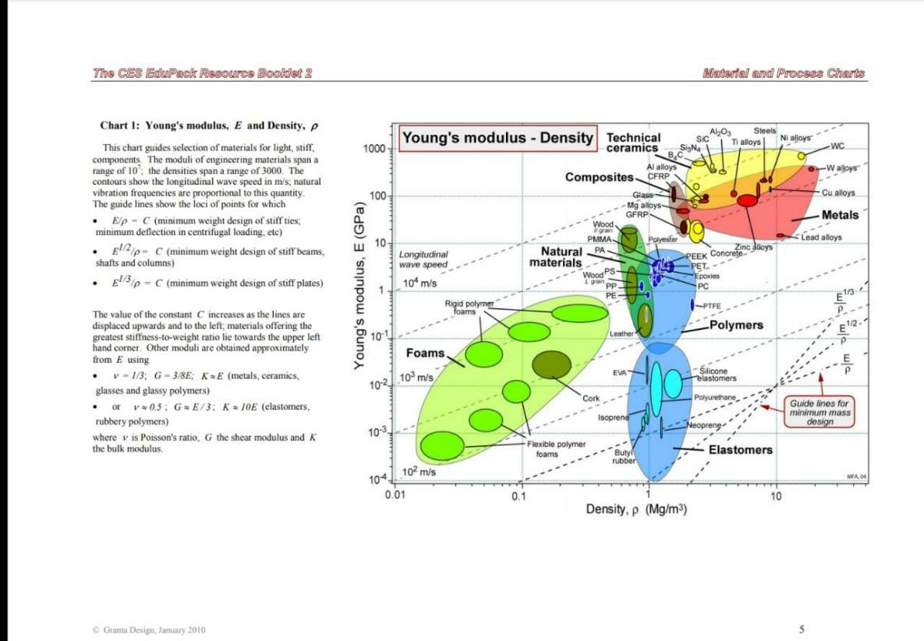

*Fig. 3.3 Young’s Modulus Vs Density Chart*

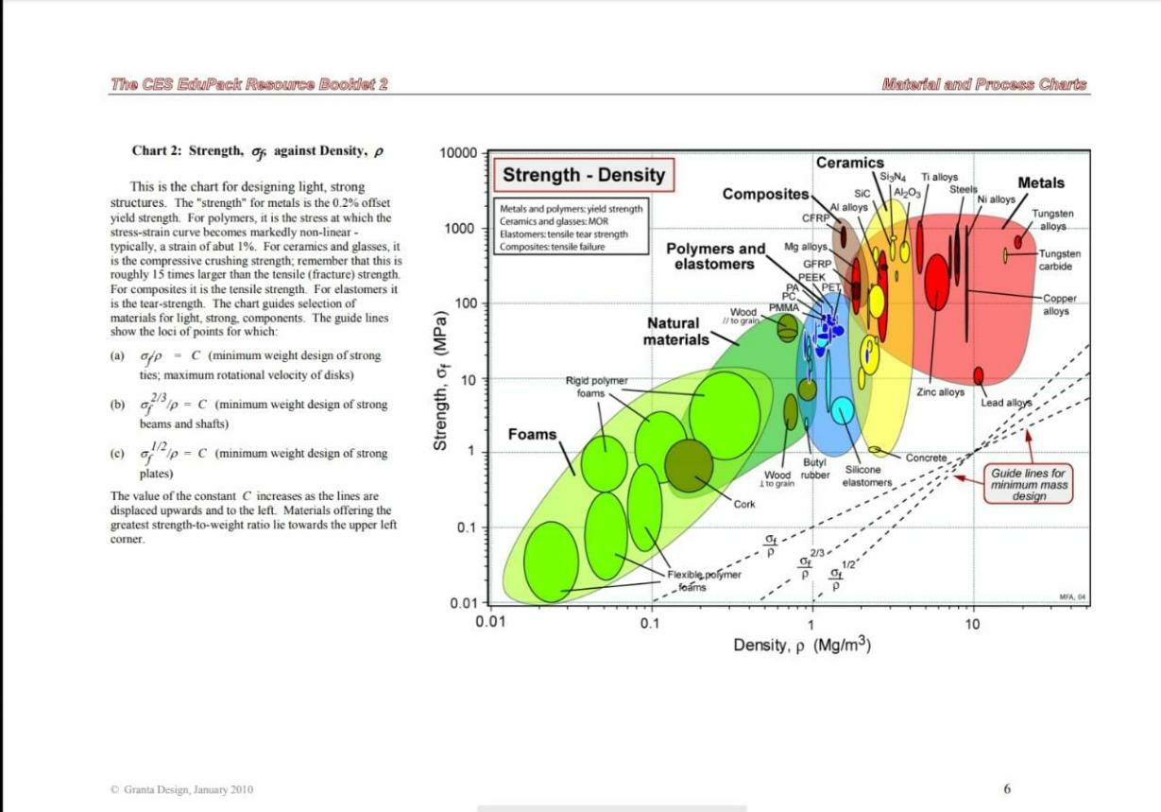

*Fig. 3.4 Strength Vs Density Chart*

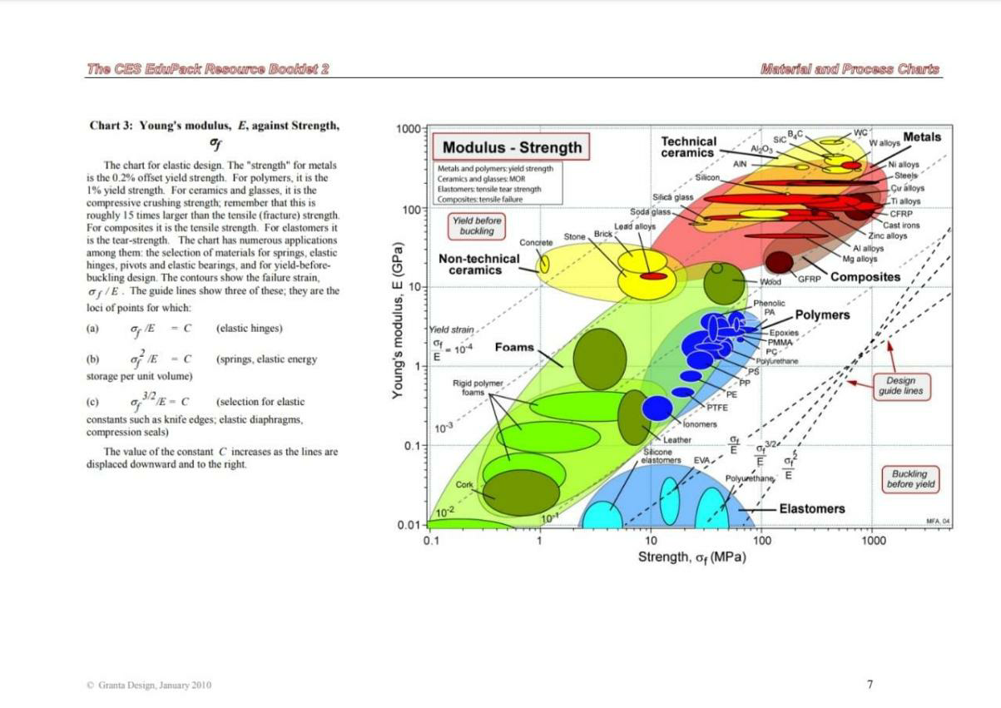

*Fig. 3.5 Young’s Modulus Vs Strength*

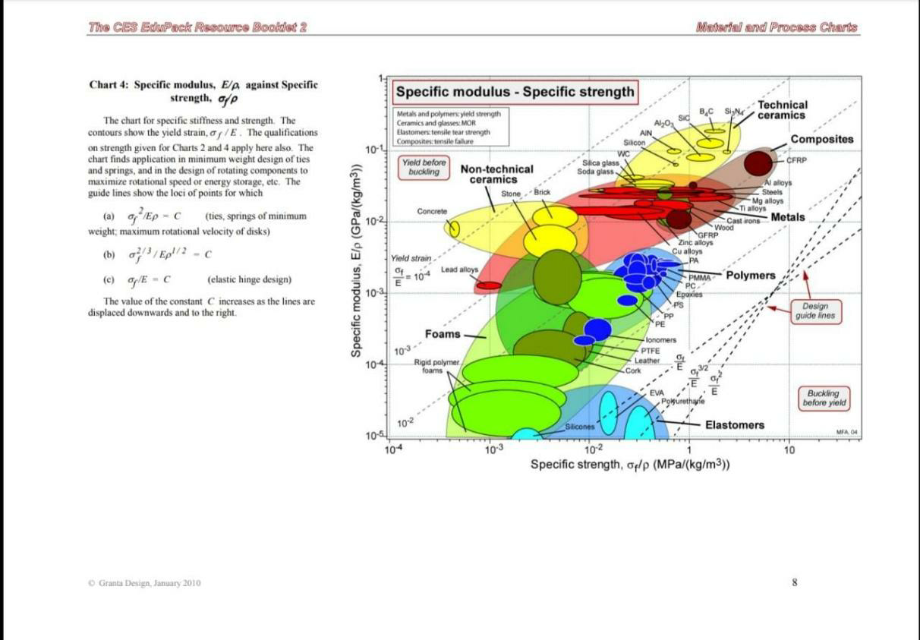

*Fig. 3.6 Specific Modulus Vs Specific Strength*

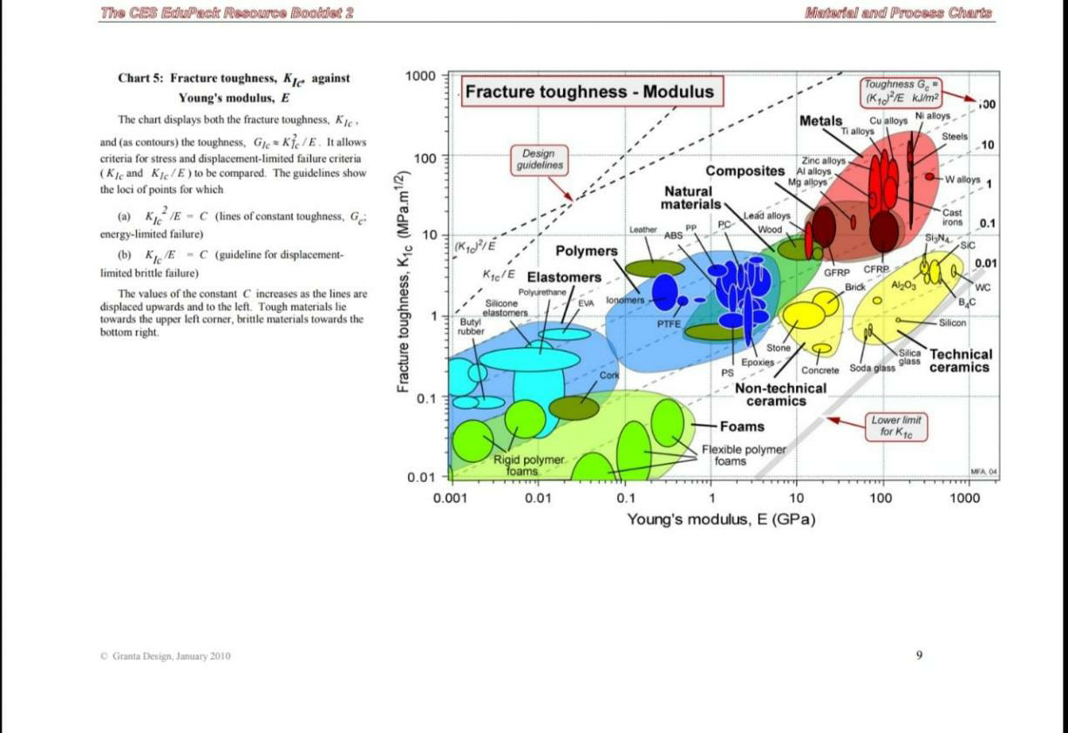

*Fig. 3.7 Fracture Toughness Vs Young’s Modulus*

**3.5 3D CAD Modelling:**

Creaion of 3D CAD Models is done with the help of Solidworks Sofware.

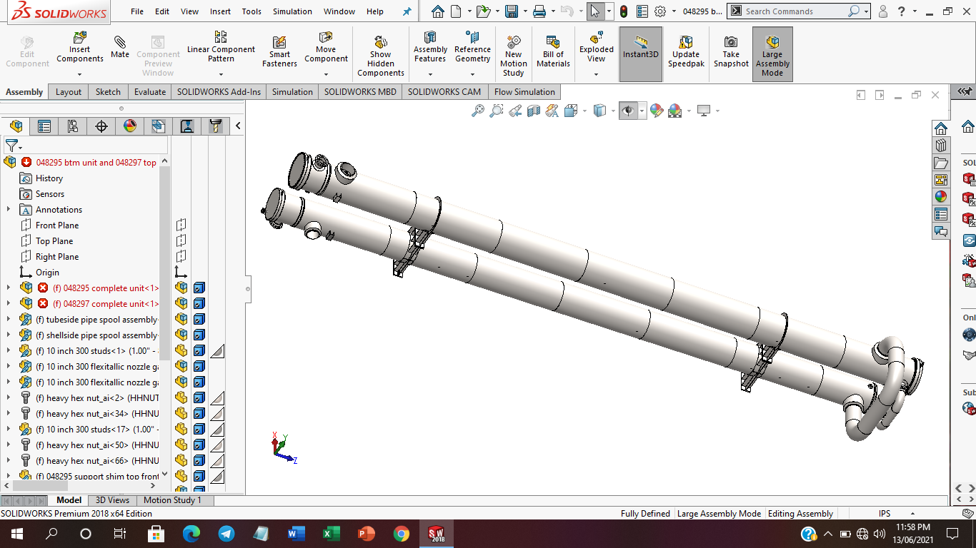

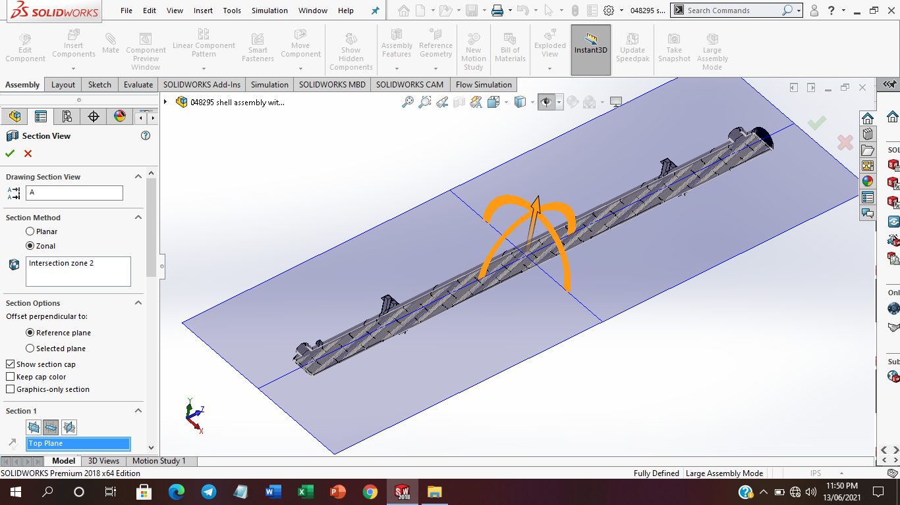

**3.6 FEA Analysis:**

**3.6.1 FEA analysis of saddle support:**

1. Material:
2. ASTM 516 Grade 70
3. IS 2002 Grade 1
4. IS 2062 Grade A
5. IS 2475 Grade 5
6. IS 2062 Grade B

These 5 materials are selected for FEA analysis.

1. Boundary conditions:
   1. Base plate is fixed
   2. Force of 39413.3 N is applied on upper bundle assembly in downward direction radially.
   3. Force of 78826.6 N is applied on lower bundle assembly in downward direction radially.
2. Results:

The table 3.4 shows result of analysis for all 5 materials. Here, for optimization of design, the thickness of center web plate is varied to bring Factor of safety between 2.5 and 3.

*Table 3.4: FEA results for saddle support*

| Material | Results | | |
| --- | --- | --- | --- |
| Equivalent Stress (MPa) | Displacement (mm) | Factor of Safety (FOS) |
| ASTM 516 GR 70 | 108 | 0.339 | 2.4 |
| IS 2002 GR 1 | 108 | 0.33 | 2 |
| IS 2062 GR A | 108 | 0.338 | 2.3 |
| **IS 2475 GR 5** | **108** | **0.377** | **2.5** |
| IS 2062 GR B | 108 | 0.356 | 1.8 |

The analysis results of IS 2475 Grade 5 material for equivalent stress is shown in figure 3.8 and displacement in figure 3.9.

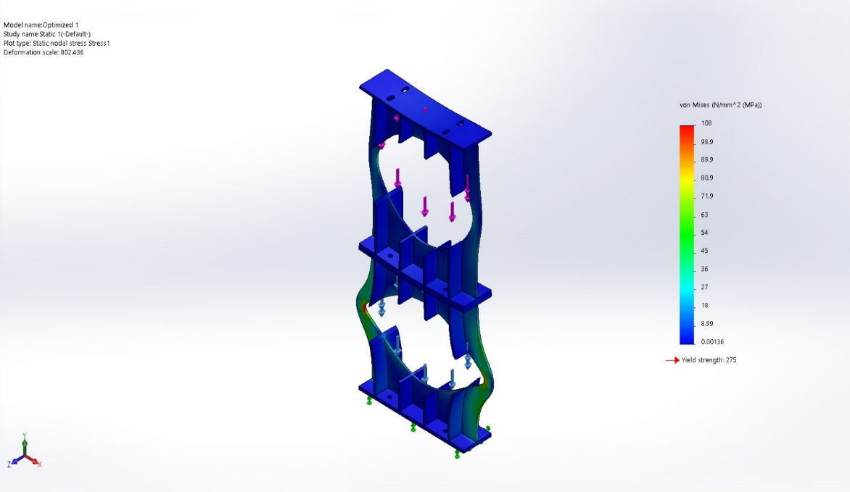

*Figure 3.8: Equivalent stress for saddle support*

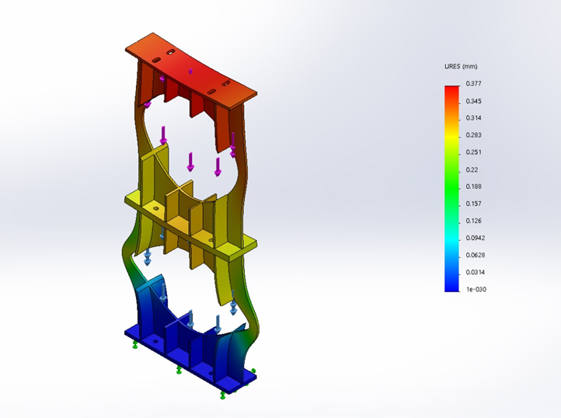

*Figure 3.9: Displacement for saddle support*

The factor of safety came in required range for IS 2475 Grade 5 shown in figure 3.10.

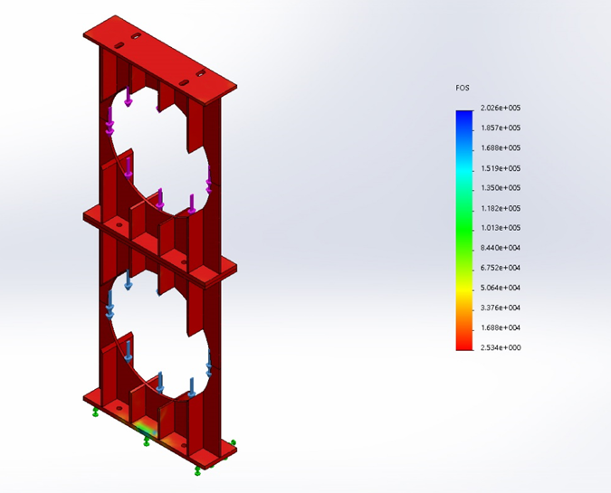

*Figure 3.10: Factor of safety for saddle support*

**3.6.2 FEA analysis of girth flange**

1. Material

*Table 3.5: FEA results for saddle support*

| 1. A105 | 1. A182 F12-2 |
| --- | --- |
| 1. A181 GR-60 | 1. A182 F304 |
| 1. A181 GR-70 | 1. A182 F304-L |
| 1. A182 F1 | 1. A182 F316 |
| 1. A182 F5 | 1. A182 F316-L |
| 1. A182 F5-a | 1. A182 F321 |
| 1. A182 F11-1 | 1. A182 F347 |
| 1. A182 F11-2 | 1. A350 LF-1 |
| 1. A182 F11-3 | 1. A350 LF-2 |
| 1. A182 F12-1 | 1. A350 LF-3 |

1. Boundary conditions
2. One side on which end cap plate is bolted is fixed.Pressure of 0.7 N/mm^2 is applied radially on inside surface.
3. Results

The table 3.6 shows result of analysis for all 20 materials. Here, for optimization of design, the factor of safety is compared and material is selected.

*Table 3.6: FEA results of girth flange*

| Material | Results | | |
| --- | --- | --- | --- |
| Equivalent Stress (MPa) | Displacement (mm) | Factor of Safety (FOS) |
| A105 | 12.3 | 1.67E-03 | 20 |
| A181 GR-60 | 12.2 | 1.66E-03 | 17 |
| A181 GR-70 | 12.3 | 1.63E-03 | 20 |
| A182 F1 | 12.3 | 1.63E-03 | 22 |
| A182 F5 | 12.3 | 1.67E-03 | 22 |
| **A182 F5-a** | **12.3** | **1.84E-03** | **42** |
| A182 F11-1 | 12.3 | 1.75E-03 | 25 |
| A182 F11-2 | 12.3 | 1.94E-03 | 22 |
| A182 F11-3 | 12.3 | 1.84E-03 | 25 |
| A182 F12-1 | 12.3 | 1.63E-03 | 18 |
| A182 F12-2 | 12.3 | 1.84E-03 | 22 |
| A182 F304 | 12.2 | 1.79E-03 | 17 |
| A182 F304-L | 12.2 | 1.79E-03 | 14 |
| A182 F316 | 12.2 | 1.79E-03 | 17 |
| A182 F316-L | 12.2 | 1.75E-03 | 14 |
| A182 F321 | 12.2 | 1.79E-03 | 17 |
| A182 F347 | 12.2 | 1.75E-03 | 17 |
| A350 LF-1 | 12.3 | 1.63E-03 | 17 |
| A350 LF-2 | 12.3 | 1.63E-03 | 20 |
| A350 LF-3 | 12.3 | 1.63E-03 | 21 |
| A105 | 12.3 | 1.67E-03 | 20 |

The analysis result of A182 F5-a material for equivalent stress is shown in figure 3.11 and displacement in figure 3.12.

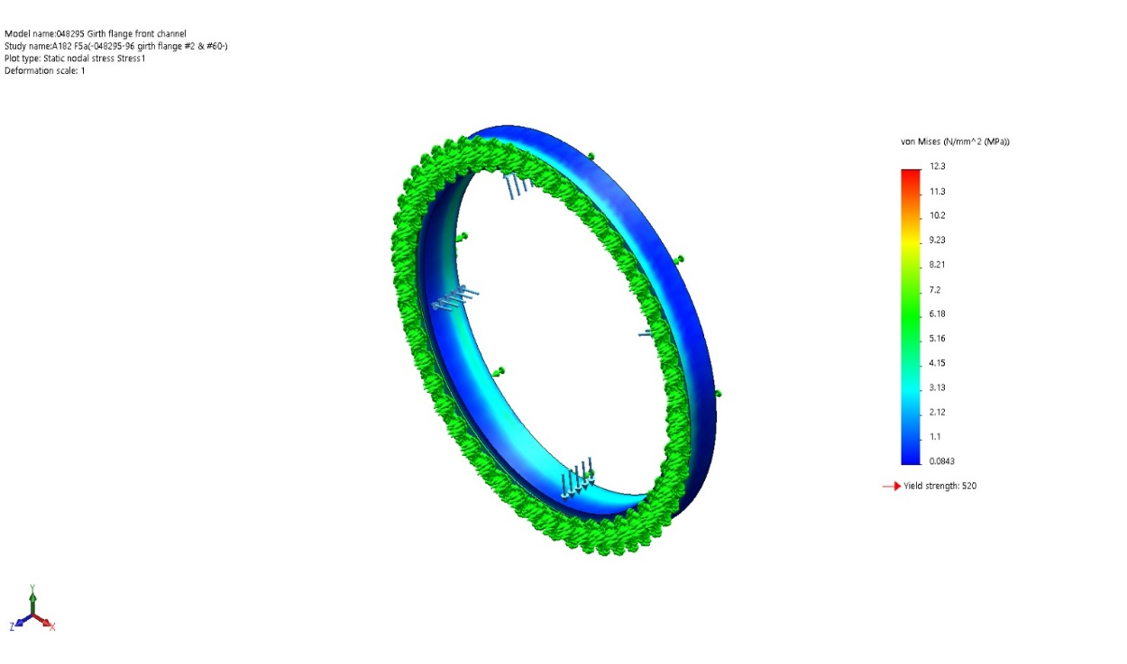

*Figure. 3.11: Equivalent stress for girth flange*

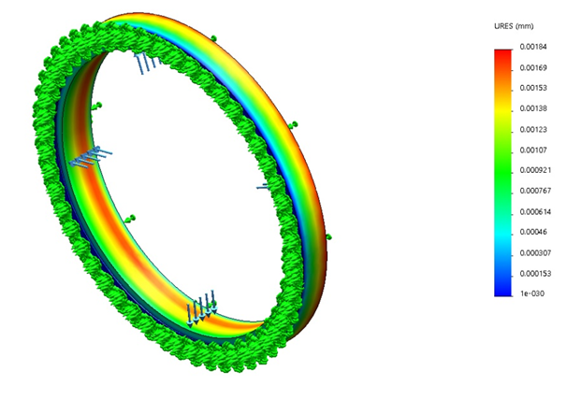

*Figure 3.12: Displacement for girth flange*

The highest factor of safety is for A182 F5-a which is shown in figure 3.13.

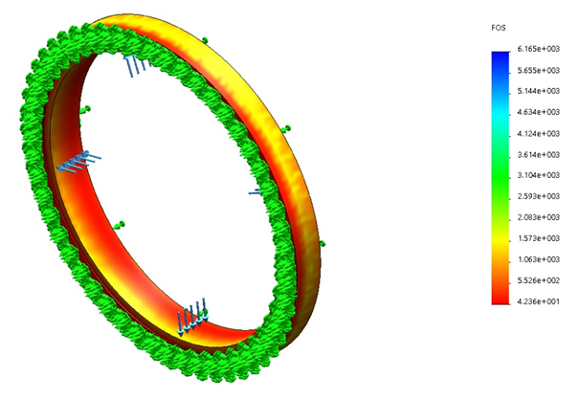

*Figure 3.13: Factor of safety for girth flange*

**3.6.3 FEA analysis of fitting pipe**

1. Material

The material used for fitting pipe is plain carbon steel.

1. Boundary conditions
2. Both the nozzle faces are fixed.
3. Pressure of 0.7 N/mm^2 is applied radially outward on inner surface.
4. Results

The table 3.7 shows result of analysis for all 13 optimizations. Here, for optimization of design, the factor of safety needs to be between 2.5 to 3.

*Table 3.7: FEA results of fitting pipe*

| Optimization | Wall thickness | Nozzle resting thickness | Results | | |
| --- | --- | --- | --- | --- | --- |
| Equivalent Stress (MPa) | Displacement (mm) | Factor of Safety (FOS) |
| Original | 12.7 | 1.47 | 397 | 0.0383 | 4.2 |
| Optimization 1 | 9 | 2 | 42.3 | 0.022 | 2.9 |
| Optimization 2 | 8 | 2 | 55 | 0.0244 | 3 |
| **Optimization 3** | **7** | **2** | **38.3** | **0.0294** | **3** |
| Optimization 4 | 6 | 2 | 36.3 | 0.0336 | 3.2 |
| Optimization 5 | 5 | 2 | 39 | 0.0397 | 4.2 |
| Optimization 6 | 12.7 | 2 | 34.5 | 0.0165 | 3.5 |
| Optimization 7 | 12.7 | 1.5 | 32.6 | 0.0379 | 4.3 |
| Optimization 8 | 12.7 | 1.4 | 36.6 | 0.0383 | 3.8 |
| Optimization 9 | 12.7 | 1.3 | 34 | 0.038 | 3.9 |
| Optimization 10 | 12.7 | 1.2 | 35.4 | 0.0384 | 3.9 |
| Optimization 11 | 12.7 | 1.1 | 83.4 | 0.108 | 2 |
| Optimization 12 | 5 | 1.9 | 157 | 0.341 | 1.4 |
| Optimization 13 | 7 | 1.9 | 126 | 0.264 | 1.7 |

The analysis result of optimization 3 for equivalent stress is shown in figure 3.14 and displacement in figure 3.15.

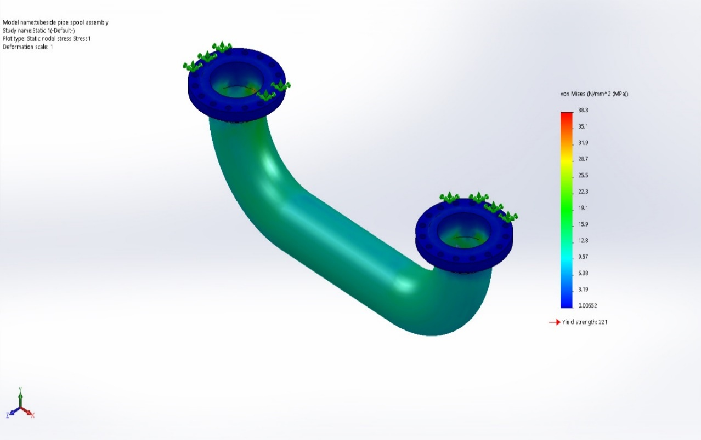

*Figure 3.14: Equivalent stress for fitting pipe*

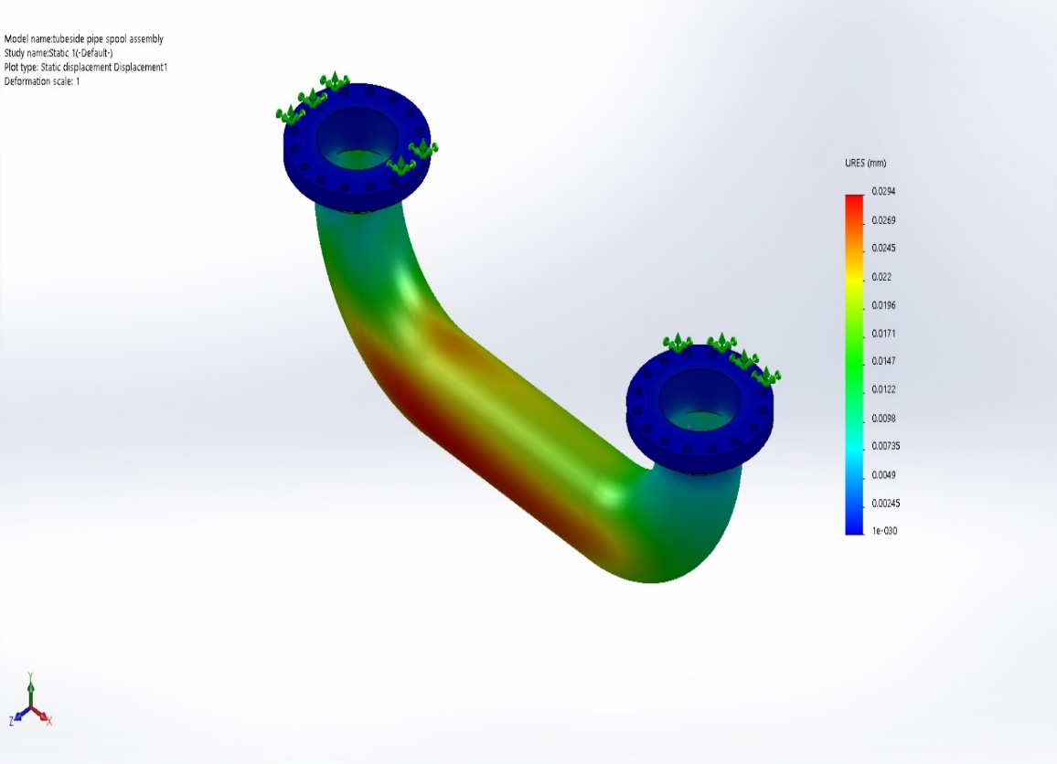

*Figure 3.15: Displacement for fitting pipe*

The factor of safety came in required range for optimization 3 shown in figure 3.16. In between optimization 1, optimization 2, and optimization 3, the FOS lies between given range but the stress generated in optimization is less, hence optimization 3 is finalizes having 7 mm wall thickness and 2 mm resting thickness.

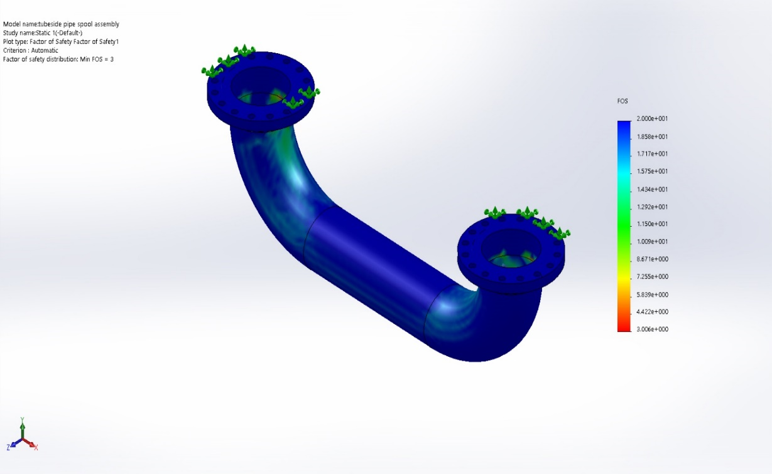

*Figure 3.16: Factor of safety for fitting pipe*

**3.7 Cost Estimation:**

**3.7.1 Material cost:**

Bottom support rear assembly

Part No. =1

Raw weight = 1155.7*31.75*304.8*4.5

---------------------------------

10^6

Raw weight = 50.3288kg

Scrap weight = 0

Total weight = 50.3288kg

Material cost = 50.3288 * 2849.99

= 143437

Part No. = 2

Raw weight = 1143*804.86*19.05*4.5

---------------------------------

10^6

Raw weight = 78.8631kg

Scrap weight = 1047294.6*7.8

---------------------------------

10^6

Scrap weight = 32.6127 kg

Total weight = Raw weight – Scrap weight

= 78.863 - 32.6127

=46.25kg

Material cost = 46.25 * 2850

= 131814 Rs

Part No. = 3

Raw weight = (329.48*304.80*19.05) +(19.05*(334.96-329.46) *304.80)

---------------------------------

10^6

Raw weight = 3.92024 kg

Scrap weight = (329.46*19.05*136.525) +(1/2*19.05*(334.96-329.46) *136.525)

---------------------------------

10^6

Scrap weight = 0.03218 kg

Total weight = Raw weight – Scrap weight

= 3.92024 - 0.03218

=3.88806*4 kg

Material cost = 15.55224 * 2850

= 44323.8 Rs

Part No. =4

Raw weight = 546.1*19.05*136.525*4.5

---------------------------------

10^6

Raw weight = 6.39134 kg

Scrap weight = ((517.44*19.05*136.525) +(1/2*19.05*(546.1-517.44) *136.525)) *4.5

---------------------------------

10^6

Scrap weight = 0.16771 kg

Total weight = Raw weight – Scrap weight

= 6.39134 - 0.16771

=6.22363 *4 kg

Material cost = 24.8942* 2850

=7094.3 Rs

**3.7.2 Welding Cost:**

Bottom support assembly:

1]Time required to weld the plate:= (length of weld)/(rate of welding)

10.16934

= - - - - - - - - - -

2.1

= 4.8425 hr.

2]Total consumption of oxygen or acetylene = oxygen consumption per hour * time

=1.1*4.8425

=5.3268 m^3

3]Effective length of filler rod = length of weld * length of filler rod required per meter

= 10.1693 * 3.4

= 34.5758 m

4] volume of filler rod = length of filler rod * cross section area

=34.5758 * (π/4) * (0.4)^2

= 3457.58 * 0.1257

= 434.4923 cm^2.

5] Cost of oxygen consumption = consumption of oxygen * cost

= 5.3268 * 15

= 79.902 Rs.

6] Cost of Acetylene = 5.3268 * 60

= 319.61 Rs.

7] Cost of filler rod = volume of filler rod * (density/1000) * cost

= 434.492*(11.28/1000)*60

= 294.1 Rs.

8]Total cost of wedding = cost of ( oxy consumption + acetylene consumption + filler rod)

= 79.902 + 319.61 + 294.1

Total cost of welding= 693.58 RS.

Front support assembly:

1]Time required to weld the plate:= (length of weld)/(rate of welding)

6.8742

= - - - - - - - - - -

2.1

= 3.27 hr.

2]Total consumption of oxygen or acetylene = oxygen consumption per hour * time

=1.1* 3.27

=8.6 m^3

3]Effective length of filler rod = length of weld * length of filler rod required per meter

= 6.8742 * 3.4

= 23.37 m

4] volume of filler rod = length of filler rod * cross section area

=2337 * (π/4) * (0.4)^2

= 293.761 cm^2.

5] Cost of oxygen consumption = consumption of oxygen * cost

= 3.6 * 15

= 54 Rs.

6] Cost of Acetylene = 3.6 * 60

= 216 Rs.

7] Cost of filler rod = volume of filler rod * (density/1000) * cost

= 293.761*(11.28/1000)*60

= 198.82 Rs.

8]Total cost of wedding = cost of ( oxy consumption + acetylene consumption + filler rod)

= 54 + 216 + 198.82

Total cost of welding= 468.82 RS.

**CHAPTER 4**

**RESULT**

**4.1 Result of FEA analysis of saddle support:**

| Material | Results | | |
| --- | --- | --- | --- |
| Equivalent Stress (MPa) | Displacement (mm) | Factor of Safety (FOS) |
| **IS 2475 GR 5** | **108** | **0.377** | **2.5** |

**4.2 Result of FEA analysis of girth flange:**

| Material | Results | | |
| --- | --- | --- | --- |
| Equivalent Stress (MPa) | Displacement (mm) | Factor of Safety (FOS) |
| **A182 F5-a** | **12.3** | **1.84E-03** | **42** |

**4.3 Result FEA analysis of fitting pipe:**

| Optimization | Wall thickness | Nozzle resting thickness | Results | | |
| --- | --- | --- | --- | --- | --- |
| Equivalent Stress (MPa) | Displacement (mm) | Factor of Safety (FOS) |
| **Optimization 3** | **7** | **2** | **38.3** | **0.0294** | **3** |

**CHAPTER 5**

**CONCLUSION AND SCOPE FOR THE FUTURE**

This project reviews the application of Heat Exchanger for industrial purpose. The study investigated the effect of change some parameters on heat transfer rate and pressure drop for shell and tube Heat Exchanger. The study concluded that as shell diameter increases the heat  transfer rate and pressure drop increases.

1. Reduction in pressure drop and increase in heat transfer rate are viable parameters to improve performance of Heat Exhanger.
2. The tubeside pressure drope is reduced by incorporating with Tube OD, Tube thickness, Tube material.
3. The Heat Transfer Rate is increase by integrating with Shell diameter, Baffle cut and Baffle spacing.

**Future Scope**

1. Reduction in vibration of saddle support.
2. Reduction in weight of saddle support.
3. Safety of Heat Exchanger can be improve.

**REFERENCES**

1. Sadik Kakaç & Hongtan Liu (2002). Heat Exchangers: Selection, Rating and Thermal Design (2nd ed.). CRC Press. ISBN 0-8493-0902-6.
2. Perry, Robert H. & Green, Don W. (1984). Perry's Chemical Engineers' Handbook (6th ed.). McGraw-Hill. ISBN 0-07-049479-7.
3. "Shell and Tube Exchangers". Retrieved 2009-05-08.
4. ] B.B. Gulyani, Estimating number of shells in shell and tube heat exchangers: a new approach based on temperature cross, Trans. ASME J. Heat Transfer 122 (3) (2000) 566–571.
5. Grzegorz Golanski, Institute of Materials Engineering, Czestochowa University of Technology, Poland. Performance of Shell and Tube Heat Exchangers with Varying Tube Layouts.